# Connect to PowerBI from ESP8266 using Arduino IDE

1. Create PowerBI Streaming dataset  
   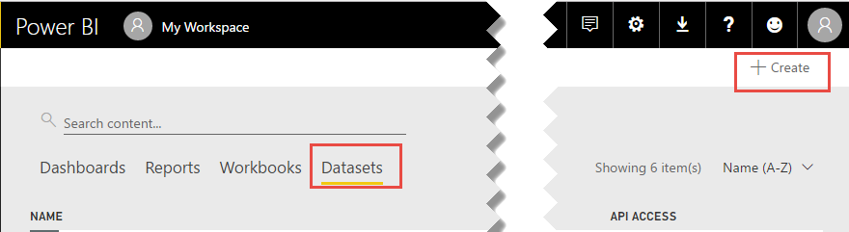  
   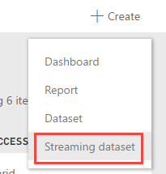  
     
   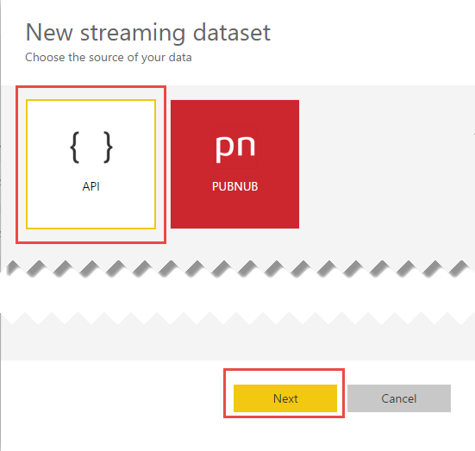  
     
   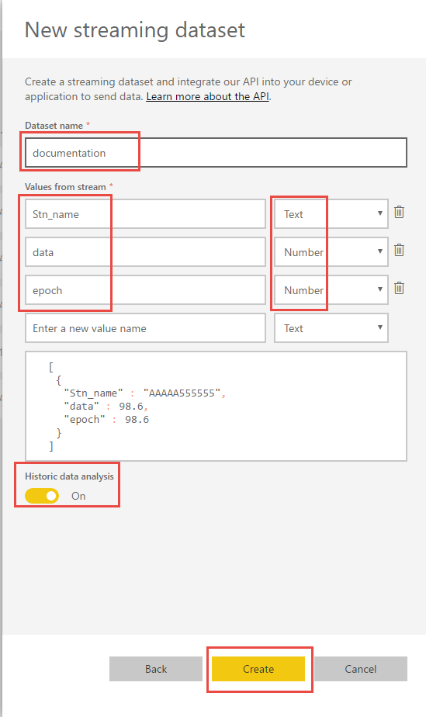  
   take note of the value names, these are the names you will send in the Arduino Stream
2. Copy the powershell example code into the clipboard and click done  
   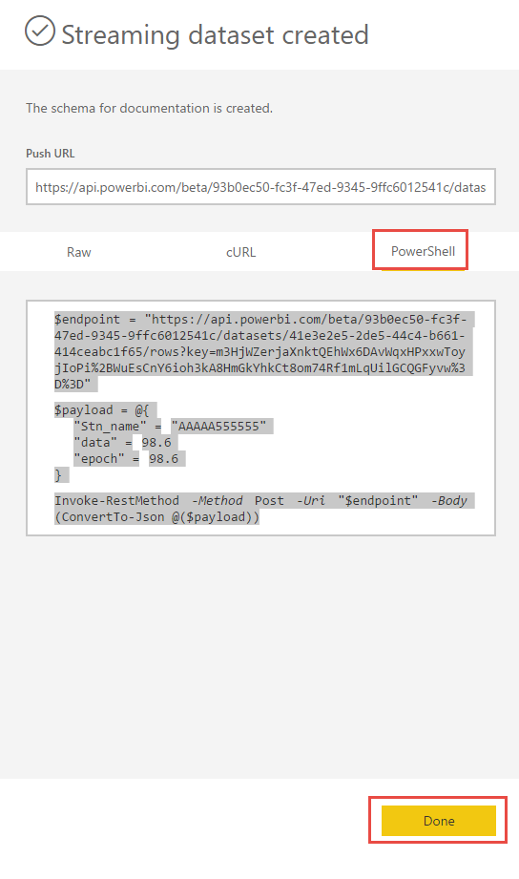
3. Paste the code into PowerShell ISE  
   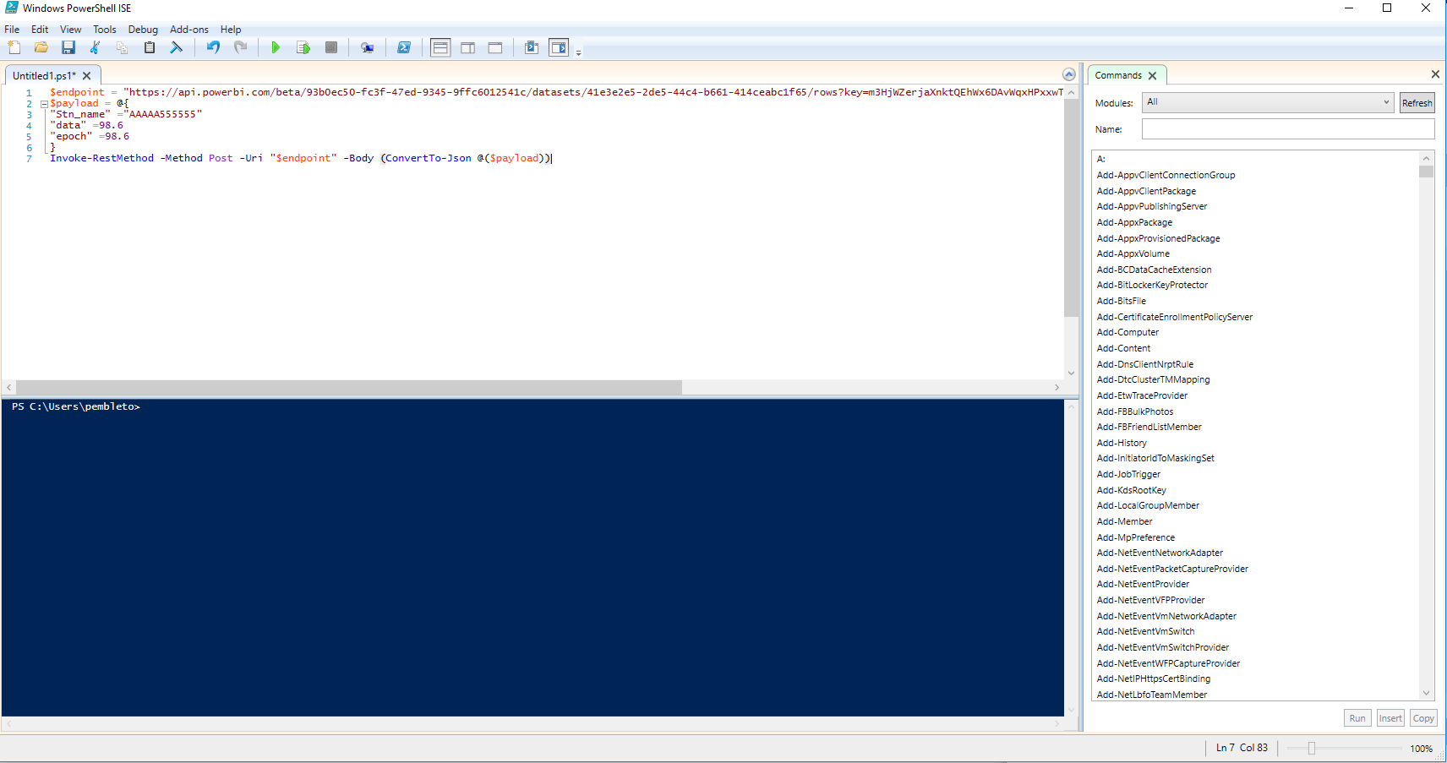
4. Start fiddler and set it to listen to https  
   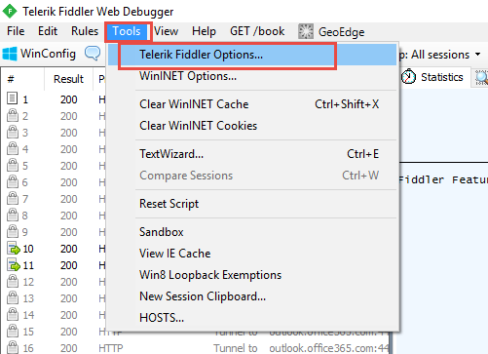  
   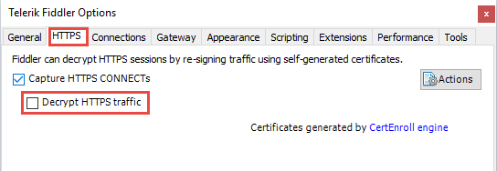  
   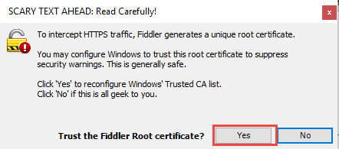  
   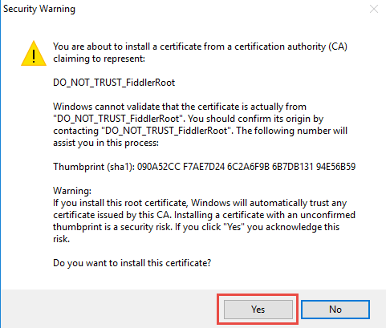  
   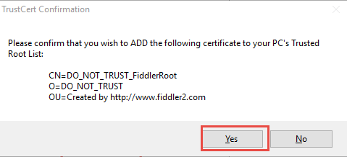
5. Capture the posting of the data from PowerShell ISE, it is the traffic to api.powerbi.com.  
   This shows the format you need the Arduino to produce  
   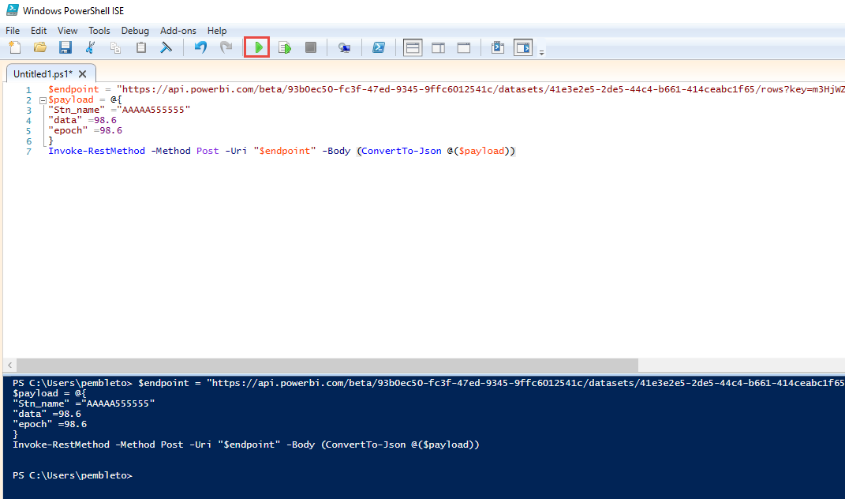  
   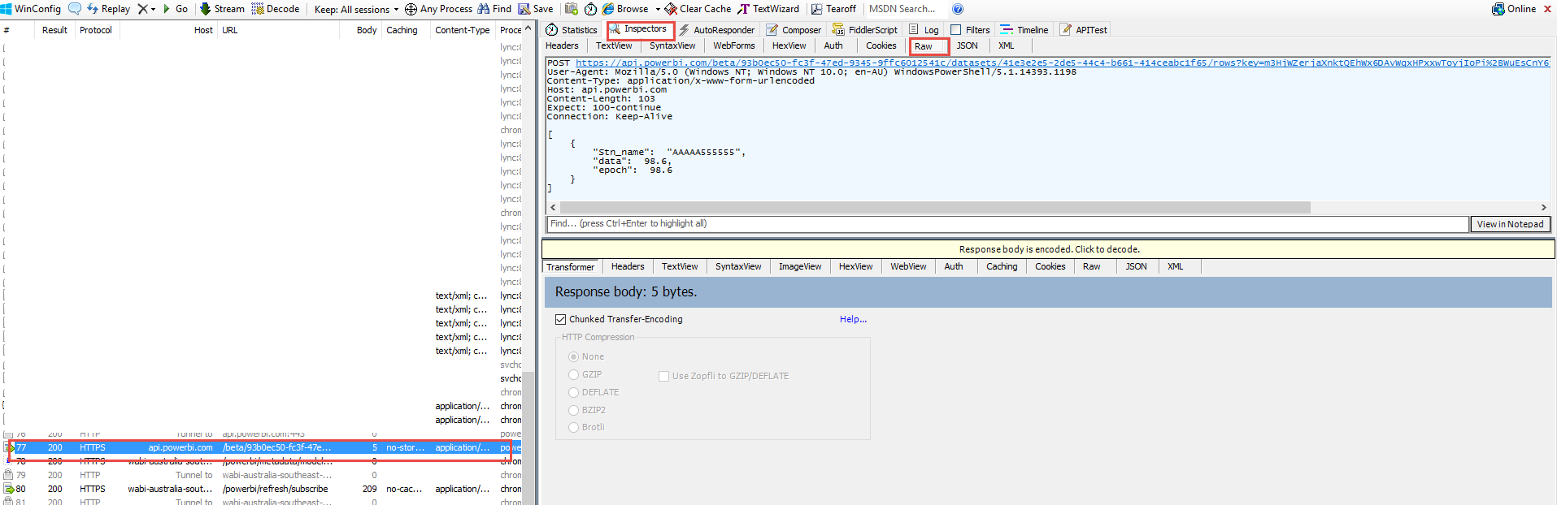
6. Copy and paste the payload data into notepad++  
   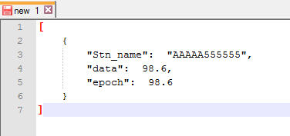
7. Remove all the white space and the values from the data, we wont bother sending the white space and we will calculate the size of the data, we just need to get the basic header size  
   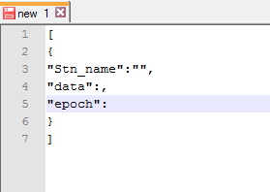
8. Highlight the data and you will see the length at the bottom of the notepad++ screen, this will give you a rough idea of what to set the variable “headerLength” to.  
   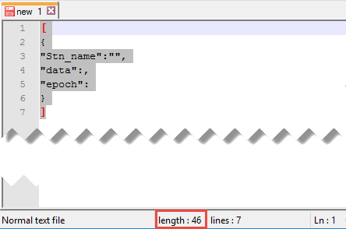
9. Update the ESP8366 code with the following values  
   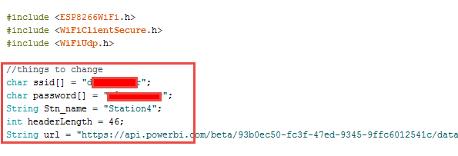
10. Upload the code and monitor the serial port, this will show you what is being sent  
    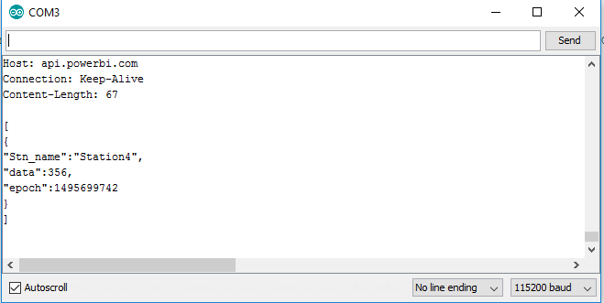
11. Copy the full POST message  
    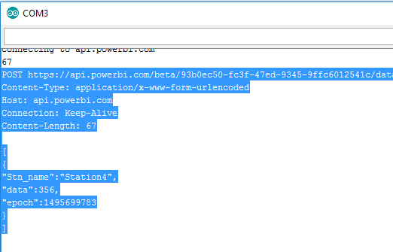
12. Paste it into fiddler “Composer” as “Raw” and click “Execute” to send the message, make sure you remove any white space off the end after the ]  
    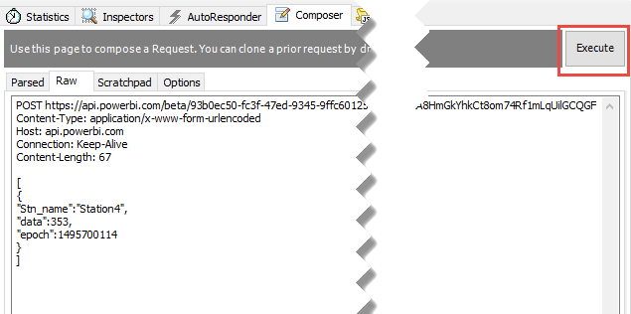
13. Inspect the packet that is sent to get the content length, it shows us 68 and we sent 67, we need to add 1 to the headerLength variable in the code  
    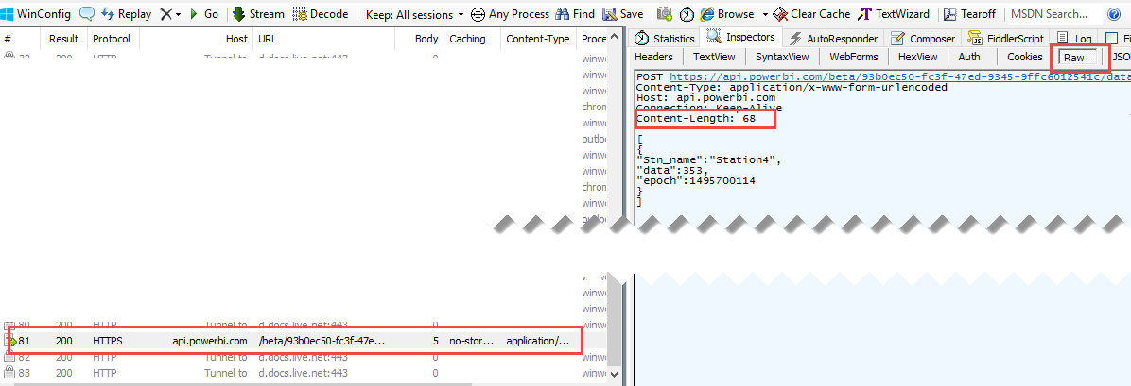  
    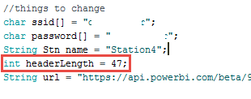
14. Redo the step from step 10, you may need to make a few adjustments to the “headerLength” to get it right

## Set up the powerBi report

1. Go back into the Datasets area and select the graph icon from the dataset you created before, this will only be there if you selected “Historic data analysis”  
   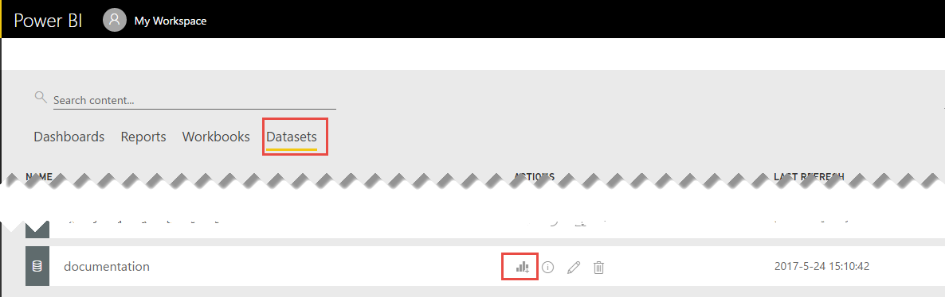
2. Add the data to a report and create some filters to remove any rubbish data from the epoch data set  
   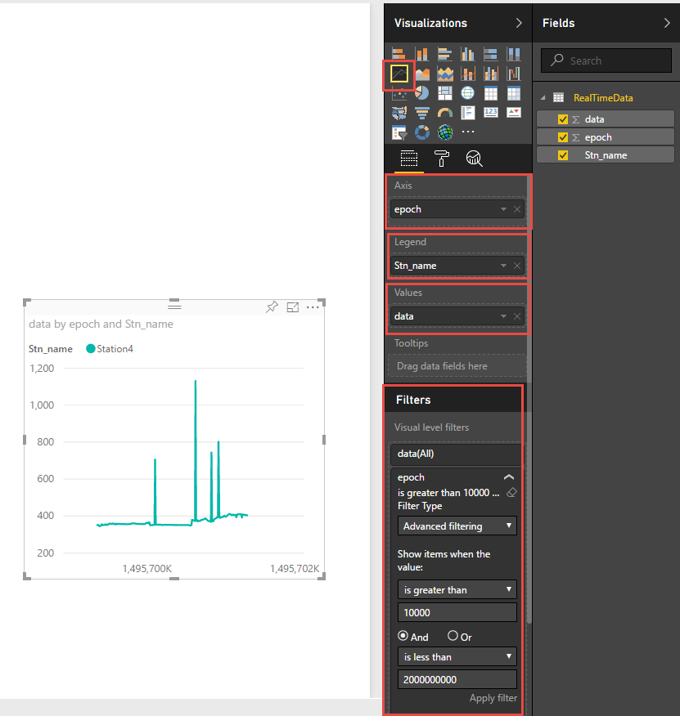

## Tips

* To add more data values to the output you need to;
  1. Add the extra fields to the streaming dataset
  2. Add the extra fields to the “SendToPowerBI function  
     
  3. Add the extra field to the length calculation  
     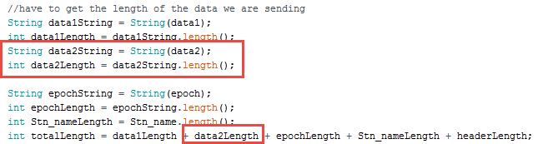
  4. Add the additional field to DataToSend, make sure you include the 3 lines  
     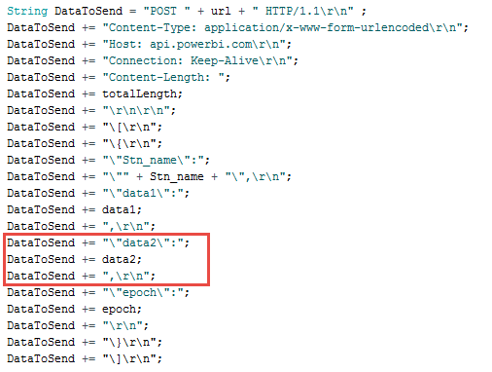
  5. If you are going over a content length of 100 you also need to add the following line into the header *DataToSend += "Expect: 100-continue\r\n";*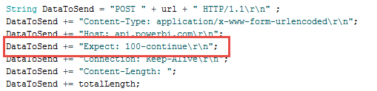

## Code for the Arduino IDE

 